Security Wrist Band for Women

Dr. Hoor Fatima   
*Assistant Professor - SET*  
*Sharda University*Greater Noida, UP, India  
hoor.fatima@sharda.ac.in

Nadeem Khan  
*Computer Science and Engineering*  
*Sharda University*Greater Noida, UP, India  
nadeemkhan7231196@gmail.com

Kunwar Vareesh Ahmed  
*Computer Science and Engineering*  
*Sharda University*Greater Noida, UP, India  
vareeshahmed@protonmail.com

Shubham Saini  
*Computer Science and Engineering*  
*Sharda University*Greater Noida, UP, India  
shubhsaini1911@gmail.com

Aman Raj  
*Computer Science and Engineering*  
*Sharda University*Greater Noida, UP, India  
aman249raj@gmail.com

*Abstract*—Mainly considering women safety in the society, it is our duty to contribute in any possible way. Having seen the safety problems in the world, the only thing we find that could help the individual is to inform the family member about the trouble anyone is facing. This project explains about the smart band security system for women. Ladies all over the globe are subjected to unscrupulous physical abuse. This is gaining momentum due to the lack of a proper monitoring system. Females are a crucial part of the community, and their safety is essential and, to a large extent, important in a strong society. Over the years, we have seen various reports of women's empowerment. A tear gas canister and video streaming live using a webcam mounted on mirrors that serve as a smart technology weapon. We truly believe that this effort will make a difference in the lives of women.

Keywords — Arduino nano, GPS, GSM, Sensors, Smart-band, Wearable Device Women Safety.

# Introduction

Today, the safety of women becomes a major issue, such apps exist, and they are equally smart to rob a victim of a phone. Here we present the band, which provides protection for women. This helps to identify women and ask for resources to help in difficult situations. The primary goal of this phone is to deliver safety and security. As independent nation women are still not safe today. The system allows you to know the exact location of the women with the device, where the belt is reloaded with an accelerometer, at a predetermined angle, and the message is automatically sent to the selected contact list. That SMS containing Latitude and Longitude information contains a self-defense shock. It sends location to a predefined contact number for latitude and longitude. When a victim attacks a woman, that time of shock.

The design is implemented using Arduino Uno connected with accelerometer, GSM and GPS systems in a modular way to accommodate different types of location tracking. Depending on the overall design of the system, the hardware and software system is a real-time monitoring system where the status of women and location information to provide immediate assistance.

## Problem Statement:

To Design a Security system for women protection with the ability to sense pulse rate, body temperature and to track their motion in the case of emergencies and take required actions.To be a compact wearable device accessible from the wrist.

## Objectives

The main objective of this project is to design an IOT Product called Security wrist band for women, this smart band belongs to wearable devices family, Security wrist band consists of the sensor layer which is able to measure the biological parameters of the women at tensed situation and triggers the messages to care takers, Objective of the project is to design small wearable band to enhance the safety of the women.

# Literature Survey

The system allows for knowing the exact location of the women who have this device, when the band is tapped and accelerometer, which is at predetermined angle, and then the message is sent automatically to selected contact list. That SMS containing location information in terms of Latitude and Longitude contains a shock mechanism for defense back. It sends the location to predefined contact numbers in the form of latitude and longitude. When the victim attacks to women that time shock circuit is used to punish the attacker for self-defense.

# Existing System

In this existing system, there is no such system for keeping the track of any girl, due to this there may occur several difficulties for them and also no safety mechanism to safe the girls from them misbehavior activities. In addition, there is no alert system for the girl’s safety, it should be done by manually only. Now a days there are plenty of bands for women safety but they are based on body temperature and blood pressure, which can't help properly. All the available bands or systems must be connected to the GPRS service to work properly, hence cannot be used during emergency if there is no internet connectivity. Mischance in arriving rate and are operated based on body temperature and blood pressures.

# Proposed Method

This study is aimed to develop a product based for the emergency security purpose. There are many safety gadgets available in the market for the purpose of emergency safety needs [4]. Main purpose of this project is to build an IOT product called Smart Security Wrist Band. This smart wrist band is a wearable device. Smart Wrist Band consists of the sensor layers which are alsocable of measuring the biological parameters of the women in any kind of tensed situation such as pulse rate and temperature and triggers an alert message to care takers or the contacts preloaded in the Arduino Nanoin the form of alert notification to the saved contacts for emergency. Also, the nearest police station will be notified with the location and details of the people in trouble. The main intention of this project is to make a small wearable watch to increase women's safety so that women can walk freely without any hesitation. This wrist band focuses over the safety of women intending to detect if there is any need for help in any situation or the person want to seek for help by pressing the SOS trigger on the watch. It calls for alerting the family members of the person wearing the band whose numbers are saved in the Arduino and the message of alert is also sent to the nearby police station with the current location of the wearer for better help.

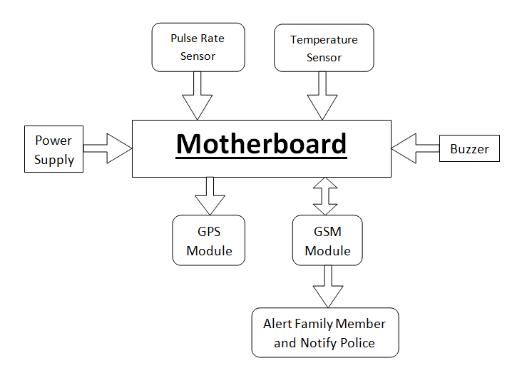

Fig.1: Block Diagram of the Model

## Arduino Nano

Arduino Nano is a small, complete, and easy-to-use bread board based on ATmega328 (Arduino Nano 3.x). It has the same or less functionality of Arduino Duemilanove, but in a different package. It just needs a DC power jug, and it works best with a Mini-B type USB cable instead of the standard one.

## GPS Module

The Global Positioning System is a location tracking system. Measures the current location with longitude and latitude details. The GPS Module used this data to get the details of the precise location of a place, such as the name of a district, a nearby street sign, etc., with a location link tracked on Google Maps [1]. That is connected to USART's small controls and provides real-time, navigation, and reliable services to global users continuously across the weather, daytime, and nighttime, anywhere in or around the globe. The GPS solution enables small form factor devices which deliver major advancements in GPS performances, accuracy, integration, computing power and flexibility. They are used to simplify the embedded system integration process. The system will only send grids of the location via SMS when GPS is turned off. Therefore, the internet is necessary.

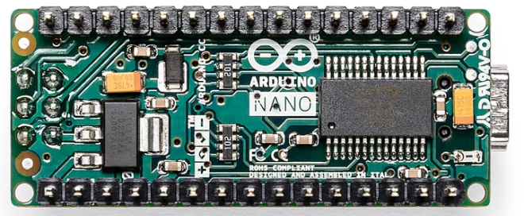

Fig.2: Arduino Nano

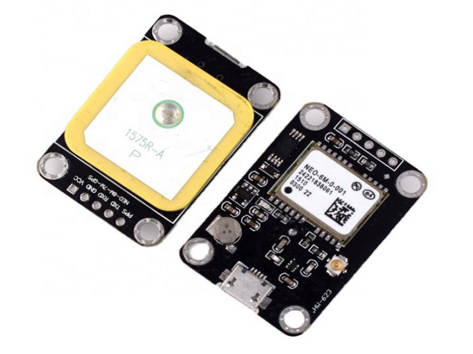

Fig.3: GPS Module

## GSM Module

The GSM module is used to establish connections between computers and the GSM-GPRS system. The GSM SIM card is inserted inside the mobile device to send and receive GPRS torture messages. Works on 900MHz 1800MHz frequency band. For any GSM Module you must have a SIM card in order to send any message.

We can use GSM 300 which operates at frequency 900MHz. It has up link band of 890MHz to 915MHz and down link Band of 935MHz to 960 MHz GSM takes advantages of both FDMA & TDMA.

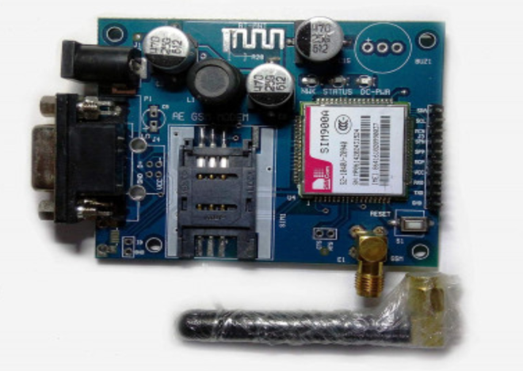

Fig.4: GSM Module

## SOS Switch

The SOS button linked to eCall, the eCall system automatically notifies the emergency services if your car is involved in an accident.

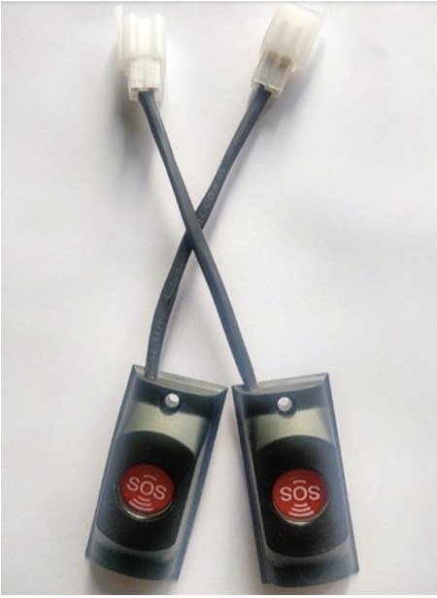

## GSM Sim Tool

SIM Application Toolkit (STK) is a standard of the GSM system which enables the subscriber identity module (SIM card) to initiate actions which can be used for various value-added services.

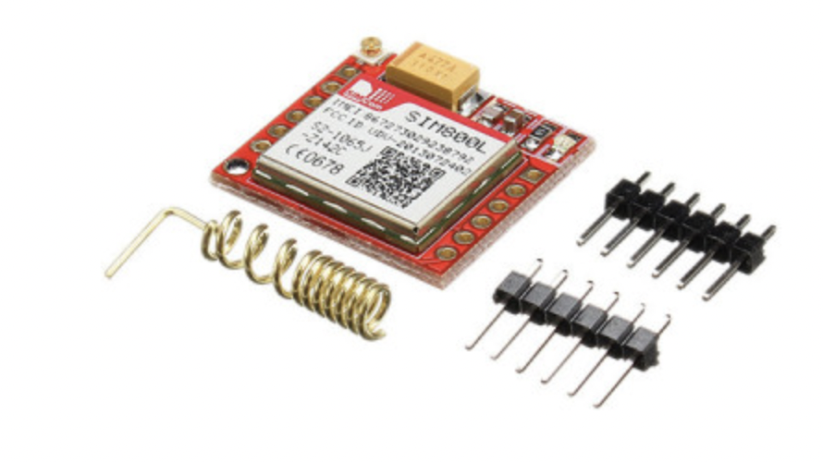

Fig: GSM Sim Tool

## Heart Rate Sensor

It is a mini device which helps keeping the record of the heartbeat frequencies over real-time for later studies. It is also capable of showing the current heart rate at the moment tested. Now-a-days there are many wrist watches which possess such sensors that detects the real-time heart rates of the person wearing the watch. This is also used to keep records of the heartbeat rates of the person throughout the day and saving that data to any database in order to keep the records for any future uses which may include monitoring of the heartbeat rates of that person for any medical purpose. These sensors are being able to give very accurate results which will definitely be benefiting our security wrist band with minimal failure results as we require it to give. In the security wrist band we will be using it as a sensor to detect the heartbeat rates of the person wearing it, in different panic or stress situation in order to trigger the SOS button when there is some unusual frequency fluctuation in the heart rate is detected.

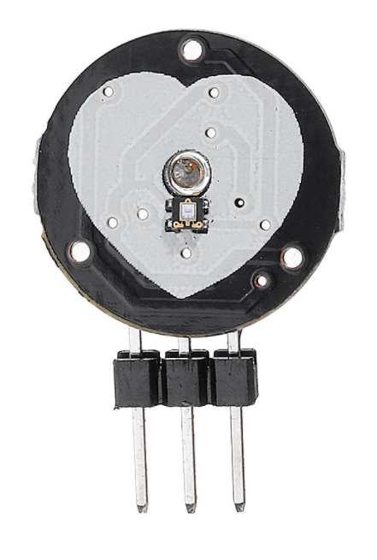

Fig.5: Heartbeat Rate Sensor

## Power Supply

A 12 volts (12V) rechargeable battery is used to power the circuit.

# Methodology

A Assembled parts will consist of a SoS button, an Arduino Nano, a GSM Module, GPS Module and a cell(s) with 12V power.

During any emergency, the person wearing the wrist band has to click on the button for the help seeking messages to be sent to her parents, nearby police station or the contacts they have chosen to send the emergency notification.

Triggering the emergency button will let the GPS module get the latitude and longitude of the band from the satellite and it will push it to the Arduino Nano. Then the Arduino Nano will send an SMS to the preloaded numbers in the Arduino Board through the GSM module connected through it (as shown in the Fig.5 below) and will send the message to the preloaded sim number with a message seeking for emergency help along with the latitude and longitude details of the person wearing the wrist band.

By this women can send an instant help seeking message along with our location for emergency help in time. This may ensure women more towards their safety and security.

Heartbeat is one of the major noticeable changes a person carries when they are in a panic situation. A human’s normal heartbeat rate is approximately 72 beats per minutes. This is examined on a large set of daily resting heartbeat databases gathered.

In a routine visit to a doctor usually experience the measurement of resting heartbeat rate by the doctor before examine to any other part of the body. This is done in order to check whether the person’s heartbeat is stable to the required rates or not. The analysis done from the large amount of dataset concludes that a person’s daily normal heartbeat rate varies from one individual to another on the basis of various attributes; such as gender, age, Body Mass Index (BMI), average daily sleep and their physical body routine.[5]

Categorising these facts together we can come to an approach to trigger our SOS in the extreme situation of fear or nervousness. The studies show that it is possible to characterise the different frequencies of heartbeat rates in different stress situation a person is in.

While a person is in stress, the heartbeat rate complexity is also affected. There are some researches which study the changes in the heartbeat rate’s frequency with respect to the short-term stress or panic and in the chronic stress situation. Body being responding to the situations is the simulation of the brain which directs the hormones to act accordingly. This can be used in order to track the heartbeat behaviour of a person in different situations or mental conditions.[6]

The heartbeat rate frequently reflects some known changes in some situation of panic or stress can be used as the trigger for this security wrist band. The band has to capture and regularly monitor the heartbeat frequency of the wearer and has the subject’s heartbeat rate knowledge in different stress situations. Finding out the situation where the heartbeat of the wearer is having unusual changes the band can act as a messenger to the person’s family members notifying them about that unknown frequency of the heartbeat of the band wearer. This will help the family person know that the person is in some kind of stress in that particular time and might be in the need of some help.

The SOS button shown in the Fig.6 below will be triggered with the help of a heartbeat rates sensor connected to it in order to trigger the button while there is an unusual change in the frequency of heartbeat of the person, which will be occurred in the situation of sudden stress or panic. Study shows there are different frequencies of the pulse rate in different mental state occurred by the situation being faced at that time. These frequencies can be different for different person according to their gender, age, physic, average daily sleep, diet and their daily routine.[5] These helps keeping the track over usual or normal heartbeat rates of that person which helps the sensor to detect the unusual or unknown frequencies that encounter in the situation of sudden stress or panic.

Having the previous data of the person’s normal heartbeat rates in different situations, it could be saved in order to have more accuracy over the successful detection of unusual heartbeat rate frequencies. This may include sudden run with pace, stopping from walking suddenly, heart beating faster in less time, etc. which can sense some different frequencies other than the person gets usually under any known calm situation.

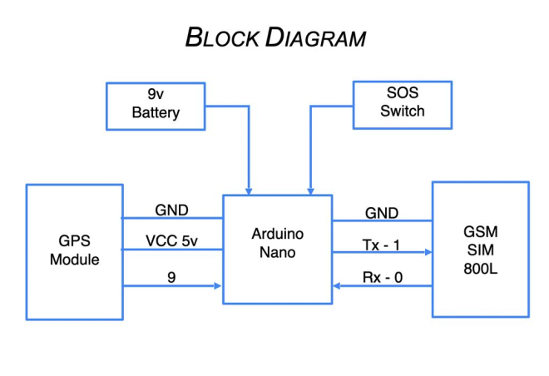

Fig.7: Systematic Block Diagram of the Wrist Band

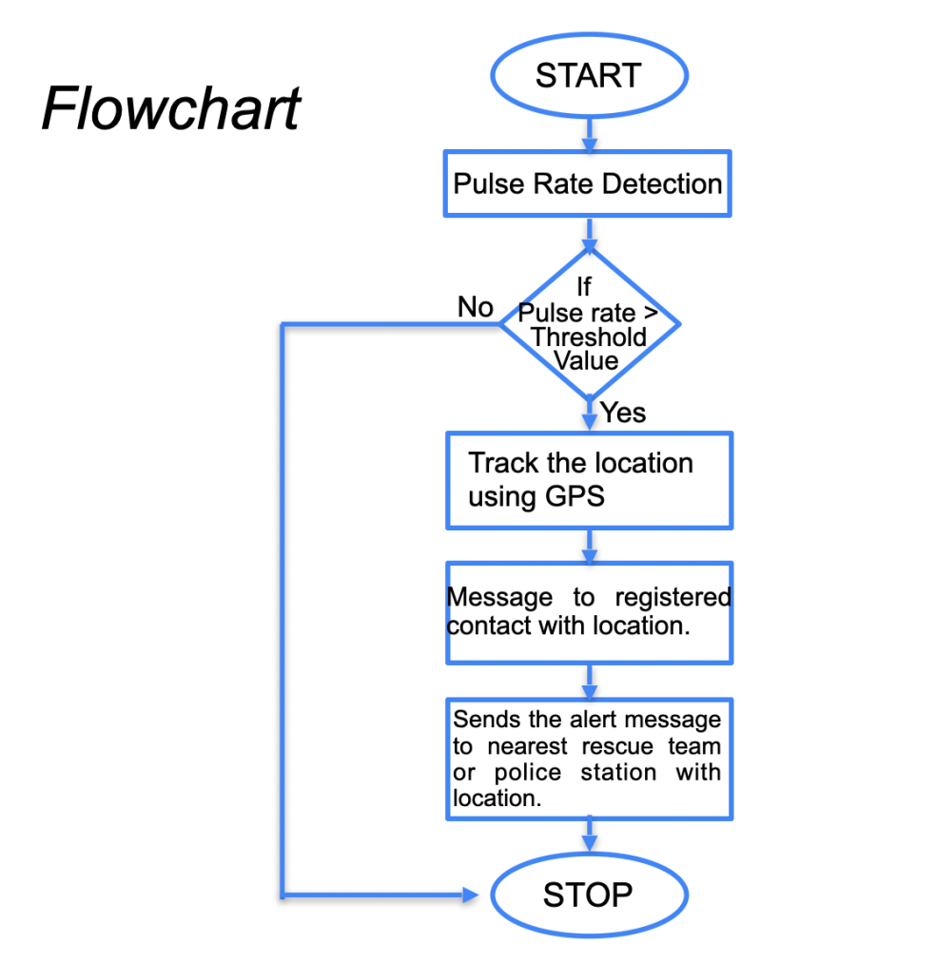

Fig 6: Flow Chart

# Software Algorithm

The following steps are initiated when once the unusual behaviour of the user is detected. The decision is made by the inputs given by the various sensors like pulse rate sensor, temperature sensor and unusual motion detected by the motion sensor. The situations are pre-programmed into the system based upon which the device makes the decision and is handled by the smart phone app.

1. Allocate the transmitter and reciever pins of GPS module.

2. Set the serial buffer with baud rate 9600 and bit rate 4800.

3. Now set a loop which will then trigger the following actions:

a) Scan the contact number from SIM.

b) Get data from GPS module.

c) Convert the longitude and latitude obtained from GPS into a Goggle URL.

d) Attach this URL with an alert message.

e) Send this message to pre-selected ICE(In Case of Emergency) numbers from SIM memory.

# Future Aspects

Focusing on adding more safety features to the product could be the addition of a GPS model which can send the exact location of the person wearing the band having more accurate latitude and longitude without the need of the internet in the area. Knowledge of the longitude and latitude will give more accuracy in finding the location. This initially can help the police to identify the location accurately, easily and faster. So that the police and the required person can reach out for help in time. Additionally the facility of calling can be introduced instead of only a message [3], as a message is sometimes not seen in time so the calling function will help to understand that the person needs help on an urgent basis.

With further research and innovation, this project can be implemented in different areas of security and surveillance. The system can perform the real time monitoring of desired area and detect the violence with a good accuracy.

# Conclusion

The nature of this project plays a very important role in providing safety to the women in the fastest way possible as a self-defense manner. This proposed design will deal with the crucial issues faced by the women in current or past scenario and will help resolve them through technological advancement. With further invention and research in this project can be integrated in various areas of security and surveillance. For selected area, this system can perform the real-time monitoring.

Finally, the conclusion is that there are various self-security bands are available in the market present-day. However, they are installed upon body temperatures and blood pressures. So there is a chance of misalignments. However, by using this self-security band, there is absolutely no chance of misalignments and errors.

##### Acknowledgment

A major project is a golden opportunity for learning and self-development. We consider our self very lucky and honored to have so many wonderful people lead us through in completion of this project.

First and foremost, we would like to thank Dr. Nitin Rakesh, HOD, CSE who gave us an opportunity to undertake this project

My grateful thanks to Dr. Hoor Fatima mam for her guidance and support in our major project work. who in spite of being extraordinarily busy with her academics, took

Out time to hear, guide and keep us on the correct path. We do not know where we would have been without her help.

**CSE** department, monitored our progress and arranged all facilities to make life easier. We choose this moment to acknowledge their contribution gratefully

Name and Signature of Students:

Vareesh Ahmed (2018002828)

Aman Raj (2018002902)

Nadeem Khan (2018008370)

Subham Saini (2018013926)

##### References

1. Personal-defense system is much mandatory for ladies with location tracking and SMS warning throught GSM network-B. Vijayalakshmi, Rauenuka.S, PooujaCheaunnur, Sharauangowda.
2. Alexaaaundros Planautelopoulous and Niikoalaos. G. Bourrbakis, *ǲA Survey on Attirable sensor based system for health tracking and Prognosis IEEE affairs on system, Man and Cybernetics, Vol.40, No.1, January 2010*
3. M. Praumod, Ch V. Uday Bhaskar and K. Shauikha. *Iot attirable device for the safety and security person needs help of ladies and girl child. Volume 6, Issue 1, January 2018*.
4. Women Safety Equipment. It is *International Journal of Information & Computation Technology.*
5. Normal resting heart rate appears to vary widely from person to person. *Science Daily (5th Feb 2020).*
6. C. Schubert, M. Lambertz, R.A. Nelesen, W. Bardwell, J.-B. Choi and J.E. Dimsdaleb. *Effects of stress on heart rate complexity - A comparison between short-term and chronic stress. National Library of Medicine.*